**Project Requirements Document**

* 1. Introduction
  + General description of the project, the vision, and objectives of the software

The projects theme is a playground. The playground has elements. Users can take actions on each element. There is a score system in the playground- when a user takes action they earn/lose points depending on the rules for each action.

* + 1.1. Purpose of System
    - What is the business purpose of the System

The initial purpose is to rate things.

At first, movies and tv shows.

Also, another possible ratings is for lectures, music, books, etc.

* + 1.2 Scope of System
    - What is part of the System Scope, and what is beyond the scope

The scope of the system includes the elements native to the playground (created in it) and the actions taken by users in the playground.

Every action taken by the users outside of the playground is out of the projects scope.

* 3. Actors and goals
  + Actors names, primary/support, Description, Goals

Player (**Primary**)- the players take actions on the elements in the playground. Depending on the action taken and the rules of the playground the players gain or lose points.

Manager (**Primary**)- the manager has his home playground which he can modify, add and remove elements. The manager can create rules in the playground and modify them. The manager does not have a score.

Guest (**Secondary**)- actor that just created an account in order to become a player/manager. They sign up to the playground and their account awaits for an approval by mail.

* 4. Functional Requirements
  + 4.1 Use Case Diagram

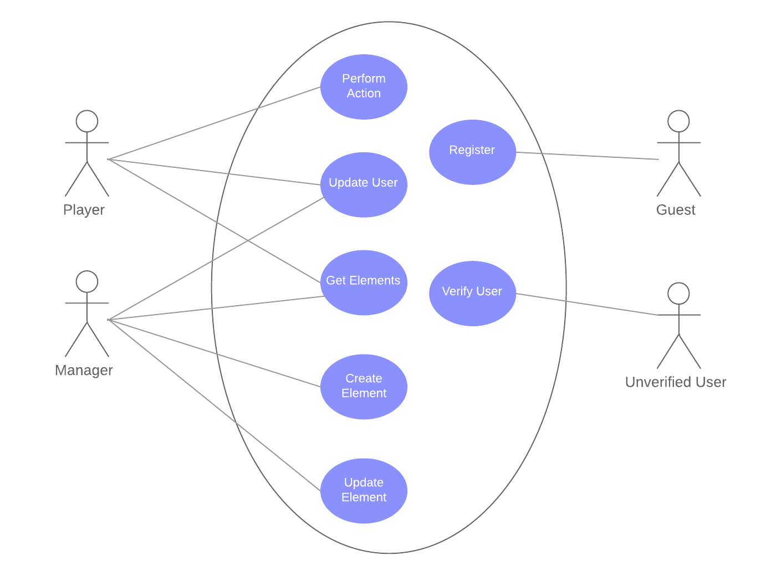

* + 4.2 Use Case Details
    - Per each use case, provide details regarding:
      * Name
      * Goals
      * Participating actors
      * Basic Workflow
      * Alternate Workflow

**U.C. Name: Register**   
Goal: Register a user to the playground  
Actors: Guest

Workflow:  
 1. The guest enters his email address, choses a role - player or manager,

username and an avatar.

2. The system creates a waiting to confirmation user and sends an email for account verification.

Alternate flow A:

1.A. On step 1, the guest already has an account in a different playground.

2.A. The guest enters his home playgrounds id

3.A. The system gets the their information and registers them as a player in this playground.

Alternate flow B:

1.B. On step 2, the entered email address doesn’t exist.

2.B. The system shows an error starts again from step 1.

**U.C. Name: Verify User**  
Goal: Verify registration of a user to the playground  
Actors: Unverified User

Workflow:  
 1. The unverified user enters his email address and verification code

2. The system verifies the confirmation code and change his state to verified

Alternate flow A:

1.A. On step 1, the unverified user enters wrong confirmation code.

2.A. The system returns an error message and the use case starts again from step 1.

**U.C Name: Update user**

Goal: update user in the playground

Actors: User

Workflow:

1. The user selects the option to update his profile.

2. The System shows a list of user attributes that can be changed.

3. The user modify the wanted attributes and send it to system.

4. The System updates the user details.

Alternate flow:

3.A. The user fill invalid details or not filling all details.

4.A. The system declined the changes.

**U.C Name: Create element**

Goal: Create element in the playground

Actors: Manager

Workflow:

1. The manager selects to create new element

2. The system shows new element form

3. The manger fills and sends the element details - location, rules, visibility and status(active/expired).

4. The system creates a new element and send it back to the manager.

Alternate flow:

3.A. The manager fills invalid details or not filling all details.

4.A. The system declined the request

**U.C Name: Update element**

Goal: Update element in the playground

Actors: Manager

Workflow:

1. The manager selects the option to show all elements in the playground.

2. The System shows a list of the playground elements that can be modified.

3. The manager chooses the element he wishes to modify.

4. The System shows update element form.

5. The manager sets the details - location, rules, visibility and status(active/expired).

6. The system approves the new changes.

Alternate flow:

5.A. The manager fill invalid details or not filling all details.

6.A. The system declined the changes.

**U.C Name: Get elements**

Goal: Get element in the playground

Actors: User

Workflow:

1. The user selects the option to show all the elements in the playground.

2. The System shows a list of the playground elements.

Alternate flow A:

1.A. The user selects the option to retrieve an element by identifiers.

2.A The System shows the requested element.

Alternate flow B:

1.B. The user selects the option to retrieve an element by identifiers.

2.B The element isn’t exists, the System returns an error message.

Alternate flow C:

1.C. The user selects the option to retrieve elements by distance.

2.C The System shows the requested list of elements.

Alternate flow D:

1.D. The user selects the option to retrieve elements by element attribute.

2.D The System shows the requested list of elements.

Alternate flow E:

1.E. The user selects the option to retrieve elements by element attribute.

2.E The selected attribute is not valid to be searched by or not exists, The System returns an error message.

Alternate flow F:

1.F. The user selects the option to retrieve a list of elements according to main flow or alternate flows C or D.

2.F There aren’t existing elements that match user request, the system return an empty list to the user.

**U.C. Name: Perform action**  
Goal: Perform action on an element  
Actors: Player

Workflow:

1. The player chooses the desired element and choose an action to be performed.
2. The system performs the action and updates the player’s score accordingly.

Alternate flow A:

1.A. The player’s action is against the rules.

2.A. The system displays an error message and the action isn’t   
 performed.

Alternate flow B:

1.B. The player’s action is to publish a message on a message board

element.

2.B. The system creates and saves a new activity and returns it to the

player.

Alternate flow C:

1.C. The player’s action is to view all messages on a message board

element.

2.C. The system creates and saves a new activity and returns it to the

player.

Alternate flow D:

1.D. The player’s action is to rate a rateable element (e.g. movie, tv show...).

2.D. The system creates and saves a new activity, with calculation of

average rating for that element, and returns it to the player.